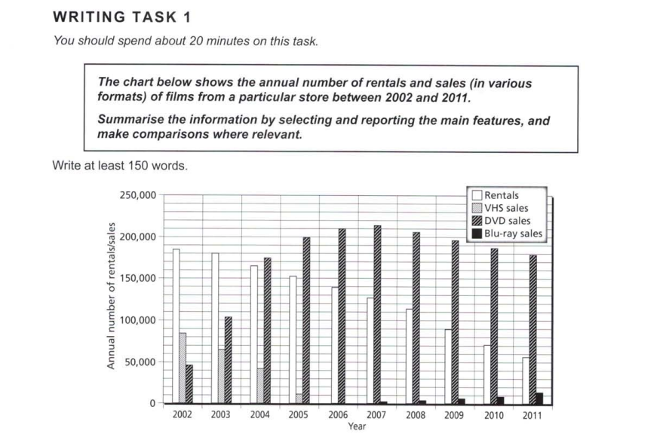

Essay Response:

The given bar chart depicts the yearly figures for the rentals and sales of different formats of films, in the 10-year timespan from 2002 to 2011. There are notable trends for each of the film formats, which shall be explained below.

Firstly, there were about 185,000 rentals in the year 2002. This figure has reduced in a linear fashion, dropping by around 100,000 per year, with it standing at just above 50,000 in the last year recorded. Interestingly, DVD sales have displayed a roughly logarithmic pattern in their numbers, with sharp increases that had slowed down by 2007, after which it has been declining gradually. The initial increases were so drastic that DVDs overtook VHS sales by 2003, then left rentals trailing behind in 2004.

The figures for VHS sales and Blu-ray show another aspect of the trends: While VHS seemed to fade out in the years between 2002 and 2006, Blu-ray purchase have been climbing at a low rate in the years after 2007. While the graph makes no indication of VHS making a comeback, if we assume that current trends continue, then Blu-ray is expected to exceed rentals in a few years after 2011.